1. What is the UVM RAL model? Why is it required?

The UVM RAL (Register Abstraction Layer) model is a layer within the UVM (Universal Verification Methodology) framework that helps in creating, managing, and interacting with the registers of a device under test (DUT) in a high-level manner. It abstracts the register definitions, their operations (like read and write), and their behavior, providing a higher-level interface to interact with hardware registers. This abstraction allows testbenches to easily interact with the DUT's registers, manage sequences, and verify the correctness of register operations.

The UVM RAL model is necessary for:

* Device Register Management: In complex designs, registers play a critical role in controlling and monitoring the behavior of the DUT. RAL provides a systematic approach to define, access, and verify these registers.
* Test Reusability: By abstracting the register operations, the testbench becomes independent of the DUT implementation, which helps in reusing the testbenches across different projects.
* Synchronization: RAL ensures that the read/write operations are synchronized with the DUT's behavior and manages register access efficiently.
* Automation: The RAL model automates the process of checking and verifying register values and interactions, improving the verification process.

1. Explain the UVM RAL with a diagram.

+----------------------------------------------------+

| uvm_reg (Register) |

| Defines a register within the DUT interface |

| - Read/Write Operations |

| - Register Field Access |

+----------------------------------------------------+

|

v

+----------------------------------------------------+

| uvm_reg_field (Field) |

| Defines the individual fields within a register |

| - Field Read/Write Operations |

+----------------------------------------------------+

|

v

+----------------------------------------------------+

| uvm_block (Block) |

| Contains a collection of registers and fields |

| - Manages groups of related registers |

+----------------------------------------------------+

|

v

+----------------------------------------------------+

| uvm_map (Address Mapping) |

| Maps register access to actual physical address |

| - Mapping of registers in memory space |

+----------------------------------------------------+

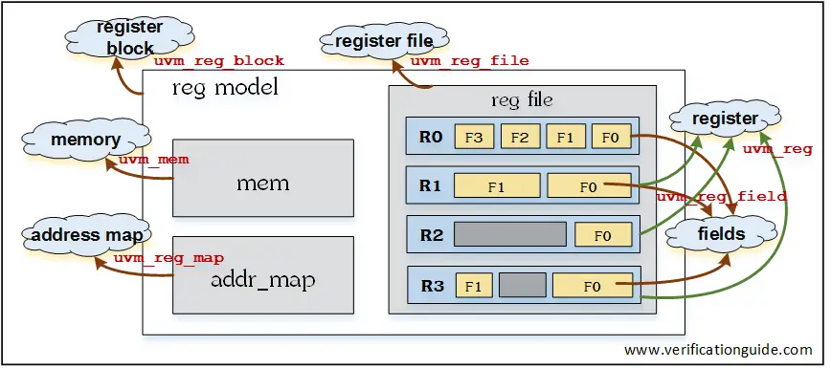

* uvm_reg: Represents a register within the DUT interface, supporting read and write operations.
* uvm_reg_field: Represents the individual fields in a register (for example, bits or bit-fields).
* uvm_block: Represents a block that contains registers and fields. It helps organize related registers into manageable units.
* uvm_map: Provides the mapping between registers and the physical memory space or address space.

1. What is an adapter? Explain with code.

An adapter in UVM RAL is a mechanism that helps in translating the register operations between the UVM register model and the physical DUT interface. It acts as an interface between the register abstraction layer and the actual DUT hardware.

Adapters are typically needed when the register model does not directly map to the DUT's interface, for example, when the DUT uses different protocols or formats for access. The adapter's job is to convert the high-level register operations into low-level protocol-specific operations (e.g., AXI, APB).

Example:

class my_adapter extends uvm_reg_adapter;

// Implement the read and write functions for your DUT interface

function uvm_status_e read(input uvm_reg reg, input uvm_sequence_item item, output uvm_reg_data_t value);

// Translate the register read operation to the DUT's protocol

value = reg.read(item); // Example: Read from the DUT interface

return UVM_IS_OK;

endfunction

function uvm_status_e write(input uvm_reg reg, input uvm_sequence_item item, input uvm_reg_data_t value);

// Translate the register write operation to the DUT's protocol

reg.write(item, value); // Example: Write to the DUT interface

return UVM_IS_OK;

endfunction

endclass

The my_adapter class extends uvm_reg_adapter and implements the read and write methods to perform the necessary translation between the UVM register abstraction and the DUT's protocol-specific operations.

1. What is a predictor? Explain with syntax.

A predictor in the UVM RAL model is used to predict the value of a register or field before actually reading it from the DUT. It can be used to validate register contents or provide expected values based on previous transactions

Syntax:

class my_predictor extends uvm_reg_predictor;

// Implement the predict function to return a predicted value

function uvm_reg_data_t predict(input uvm_reg reg);

uvm_reg_data_t predicted_value;

// Logic to predict the register value based on certain conditions

predicted_value = 32'hDEADBEEF; // Example of a predicted value

return predicted_value;

endfunction

endclass

The my_predictor class extends uvm_reg_predictor and implements the predict function. In this case, it returns a predicted value (DEADBEEF) for the register reg.

1. What are the different layers in RAL model? Explain in detail.

* Register Layer (uvm_reg):
  + Defines a register with specific properties, such as access type (read/write), reset value, etc.
  + Responsible for the high-level operations of interacting with individual registers.
* Register Field Layer (uvm_reg_field):
  + Defines individual fields within a register, like bits or bit-fields.
  + Provides the mechanism for accessing and manipulating specific bits of the register.
* Block Layer (uvm_block):
  + Groups-related registers into a block.
  + Represents logical groupings of registers (e.g., control register blocks).
* Address Mapping Layer (uvm_map):
  + Maps logical registers to physical memory locations.
  + Allows the register access to be mapped to a specific address space or bus protocol.
* Adapter Layer (uvm_reg_adapter):
  + Provides a bridge between the UVM RAL and the actual DUT interface.
  + Translates the UVM register operations (read/write) into low-level transactions that the DUT understands.

1. Explain the following classes:
   1. uvm_reg_field: Represents a single field in a register. A field could be a single bit or a group of bits (e.g., a 4-bit field within a register). It is used to model register bits or fields of a register.
   2. uvm_reg: Represents a register within the DUT. It can contain multiple fields (uvm_reg_field) and can support operations like read, write, and reset.
   3. uvm_mem: Models a block of memory. It is used to represent and manipulate a block of memory in a testbench, typically simulating memory access operations such as read, write, and memory checks.
   4. uvm_block: Represents a block of registers. This class helps in grouping related registers together. A block could represent a memory-mapped region or a set of related control registers.
   5. uvm_map: The uvm_map class handles the mapping between the register abstraction and the physical memory address. It allows registers to be mapped to specific addresses in the address space of the DUT.